1.Pointer arithematic:

Write a C program to create an integer array of size 5, initialize it with values from 1 to 5, and then use pointer arithmetic to print each element of the array.

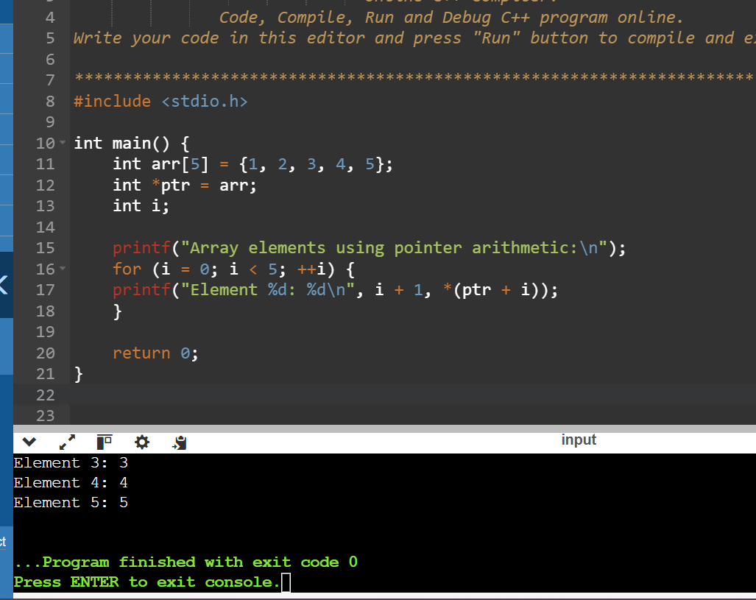

2.) Pointer to Pointer:

Write a C program to create a pointer to a pointer for an integer variable. Initialize the integer variable with a value, and then print its value using both the single pointer and the pointer to pointer.

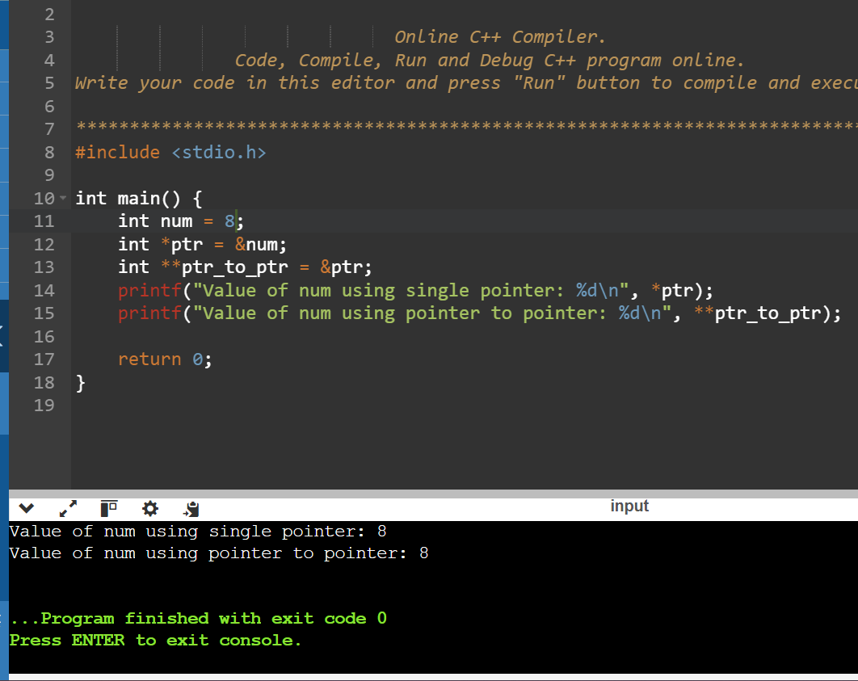

3.) Pointer Function Parameters:

Write a C function void swap(int \*a, int \*b) that swaps the values of two integers. Then, write a main function to test this swap function using pointer arguments.

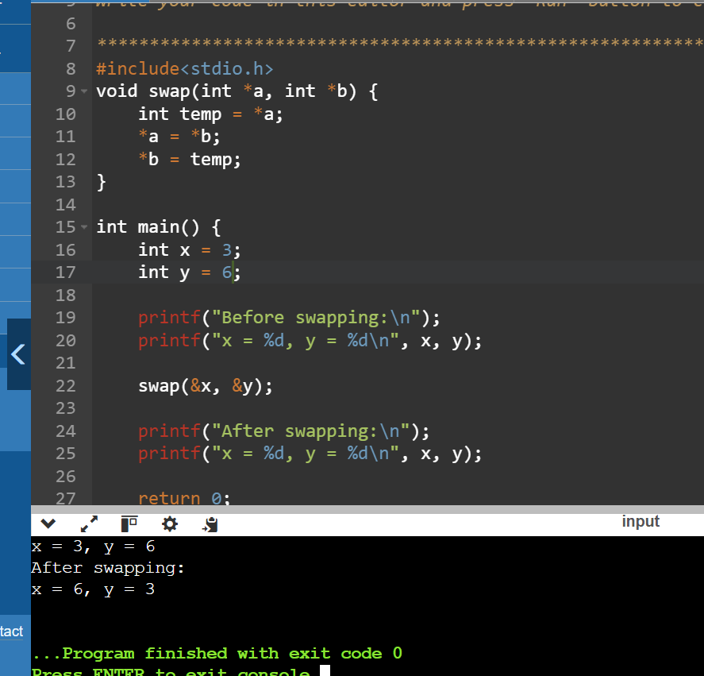

Pointer to Function:

Write a C program to create a function pointer that points to a function int add(int, int). Use the function pointer to call the add function and print the result.

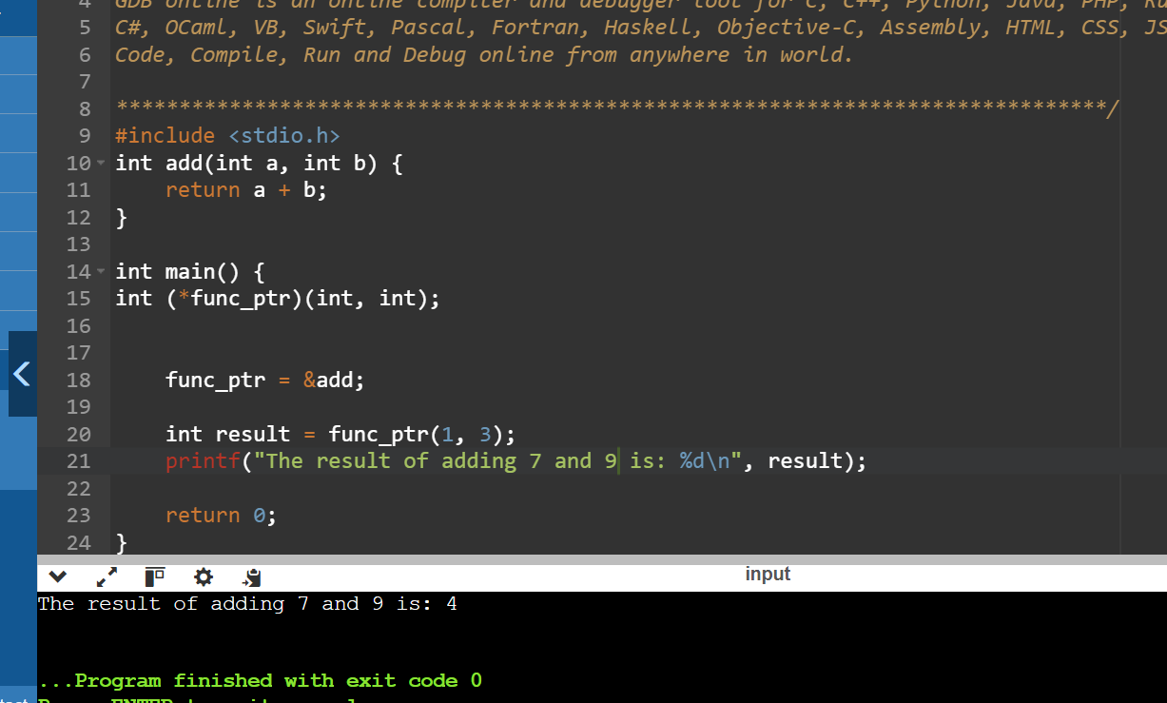

Array of Function Pointers:

Write a C program to create an array of function pointers, where each function takes two integers as arguments and returns an integer. Include functions for addition, subtraction, multiplication, and division. Use the array to perform these operations on two integers and print the results.

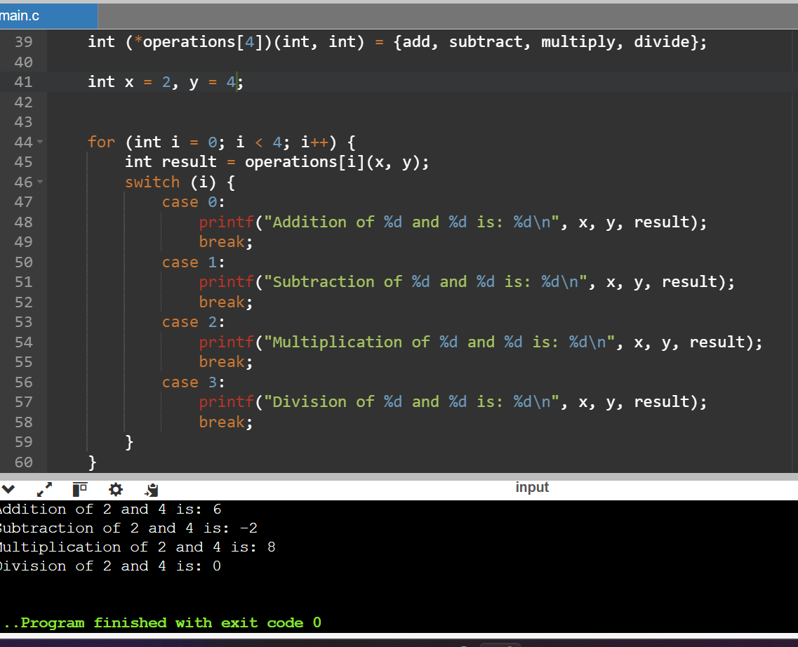

Structures

1. Structure basics:

Define a structure struct Point with two integer members x and y. Write a C program to create a Point variable, initialize it with values, and print the values.

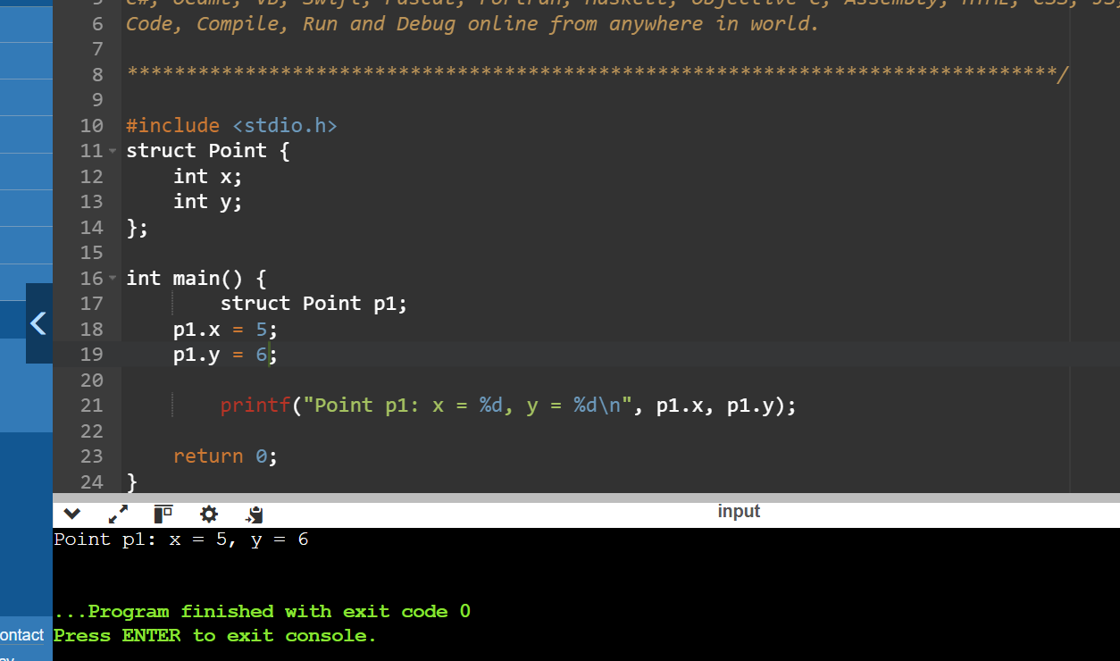

Array of Structures:

Write a C program to define a structure struct Student with members name, age, and marks. Create an array of 3 students, initialize them with values, and print the details of each student.